Group

AI Based Recommendation System For

Career Guidance

Software Requirements Specification:

Xampp, Vs-Code and MySQL

**Project Guide: Dr. Poonam Tanwar**

**Members:**

Y.Zakir Fakruddin

Roll no. :1/19/FET/BCS/150

Divyansh Singh

Roll no. :1/19/FET/BCS/131

Aryan Gaur

Roll no. :1/19/FET/BCS/144

**College Name:** Manav Rachna International Institute of Research and Studies

**Department Name:** Faculty of Engineering & Technology

Table of Contents

1. Introduction
   1. Purpose
   2. Scope
   3. References
   4. Technologies to be Used
   5. Overview
2. Overall Description
   1. Working Model
   2. System Requirements
3. **Introduction:**

A Career Recommendation is a filtering system that seeks to predict and show the career path that a user would like to opt for in coming future. It may not be entirely accurate, but if it shows what a user is capable according to the provided input skills, then it is doing its job right.

Recommendation engines basically are data filtering tools that make use of algorithms and data to recommend the most relevant items to a particular user. In simple terms, they are nothing but an automated form of a “shop counter guy”.

In this project, we presented our project that is recommendation system that recommends career options for a given user based on a hybrid approach which is a combination of content-based (using user’s past history or choice) and collaborative approach (using other similar user’s choice).

For this project, we have used dataset, on the basis of which our model is able to recommend the right career path for the user. The algorithm which we used for the recommendation system is KNN(K-Nearest Neighbor) algorithm.

* 1. **Purpose:**

In today’s world there are many career option for a student, this makes a student to choose wrong path for his/her career. Therefore to over come this problem we going to develop a AI Based Recommendation System for Career Guidance for students which help the students to choose the right path for the better future.

Once Steve Jobs said: “*A lot of times, people don’t know what they want until you show it to them.*” So from this project we going to recommend students the right career path to follow for their better future which they might don’t know about.

* 1. **Scope:**

The scope of our project is to develop a recommendation system using machine learning algorithm in which we will be having a data set, with the help of the data set the model will be providing the required output on the basis of users input.

We will also develop a website through which we are going to take the input of the user and provide to required output on the site it-self.

We will be using a data set through which the algorithm will find the right career path to choose for an individual user, this algorithm will be finding the similarities between the user input and the data set and give the appropriate results.

* 1. **References:**
* Das, Debashis, Laxman Sahoo, and Sujoy Datta. "A survey on recommendation system." *International Journal of Computer Applications* 160.7 (2017).
* Tan, Huiyi, Junfei Guo, and Yong Li. "E-learning recommendation system." *2008 International conference on computer science and software engineering*. Vol. 5. IEEE, 2008.
* Subramaniyaswamy, V., and R. Logesh. "Adaptive KNN based recommender system through mining of user preferences." *Wireless Personal Communications* 97.2 (2017): 2229-2247.
* Ahuja, Rishabh, Arun Solanki, and Anand Nayyar. "Movie recommender system using K-Means clustering and K-Nearest Neighbor." *2019 9th International Conference on Cloud Computing, Data Science & Engineering (Confluence)*. IEEE, 2019.
* Patro, Sunkuru Gopal Krishna, et al. "A hybrid action-related K-nearest neighbour (HAR-KNN) approach for recommendation systems." *IEEE Access* 8 (2020): 90978-90991.
  1. **Technologies to be used:**
* **Text Editor(Vs-Code):** This text editor is used to write the code to develop the website as well as the to run the python libraries.
* **Xampp:** This is a server hosting application which helps the PHP files to run and perform all task on the local-host.
* **MySQL:**
  1. **Overview:**

AI Based Recommendation System for Career Guidance. The problem of students not able to choose the right path for their future is the lack of information and lack of mentorship, this leads to the wrong career path and failure in their future goals.

With the help of our career recommendation system the students get to know the different career path available for them, know their interests and the skills needed to get better. This helps the students to choose the right path for their future and reach their goals.

In this recommendation system we will be providing 15-17 skill set and subjects and the user needs to provide the proficiency level with 7 different level. After the input is provided to the KNN model, the model will search for the most suitable career path from the database which has most similar data to the available category of data.

1. **Overall Description:**
   1. **Working model:**

Below is a similar recommendation model on which we are going to make our project.

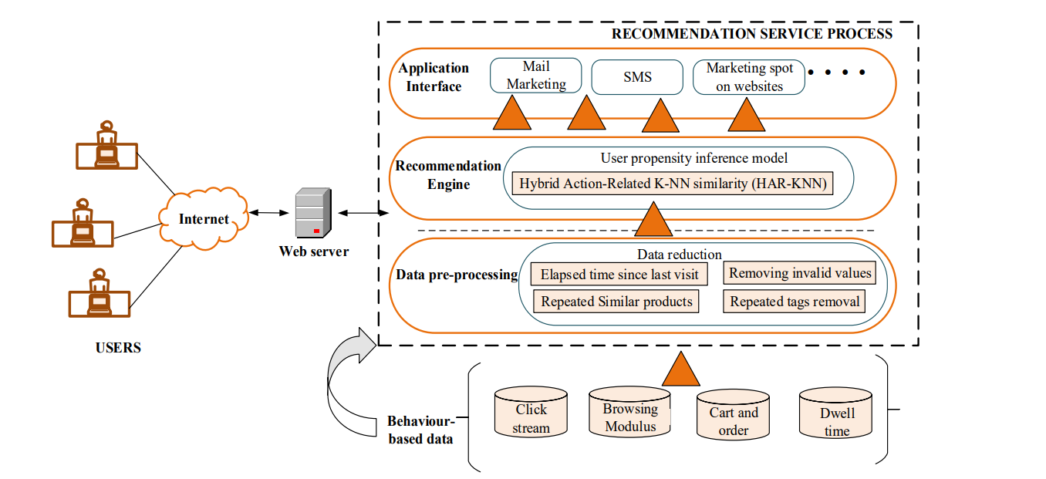

* 1. **System Requirements:**

The are the minimum system requirements to develop and run the recommendation project.

* + 1. **Hardware specifications:**
* A Laptop with Windows/Linux operating System.
* Processor with more 1.7gHz speed.
* Minimum 4gb of Memory.
* Minimum 5gb of empty Storage.
* An Integrated Graphic card.
  + 1. **Software specifications:**
* Text Editor (Vs-Code)
* Xampp
* Python Libraries
* MySQL